Assignment Sheet – 2
Name – Sayak Sen
Enrollment No – 2023CSB047
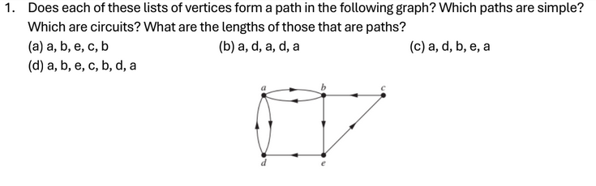
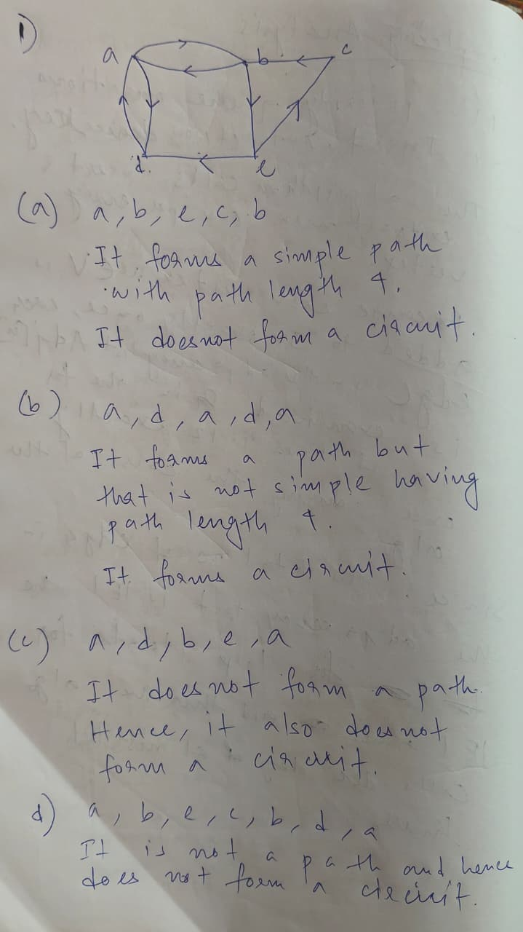
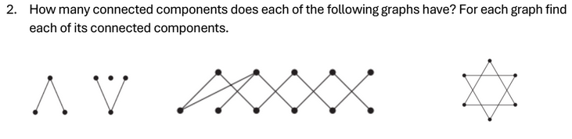
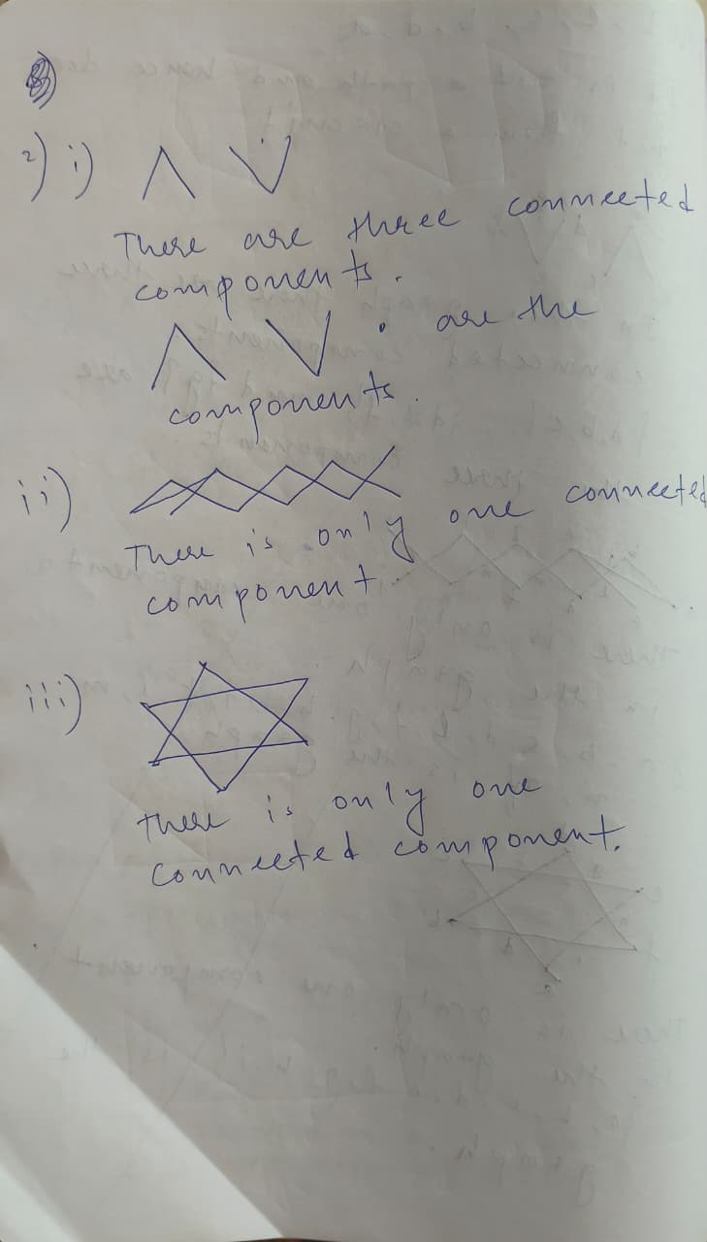
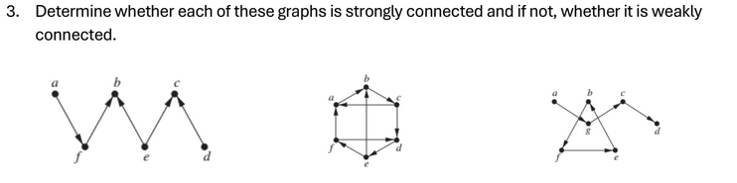
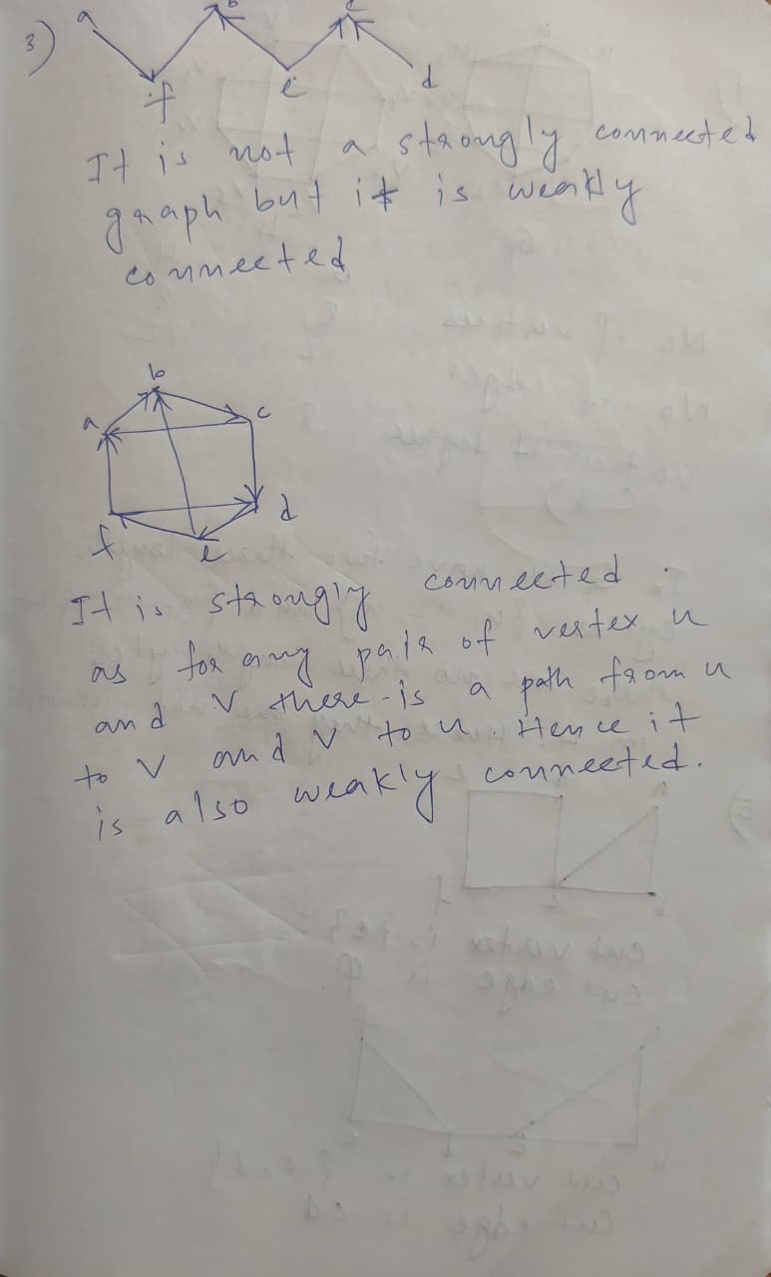

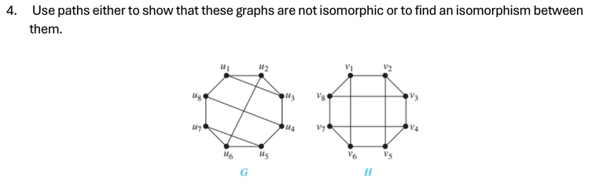
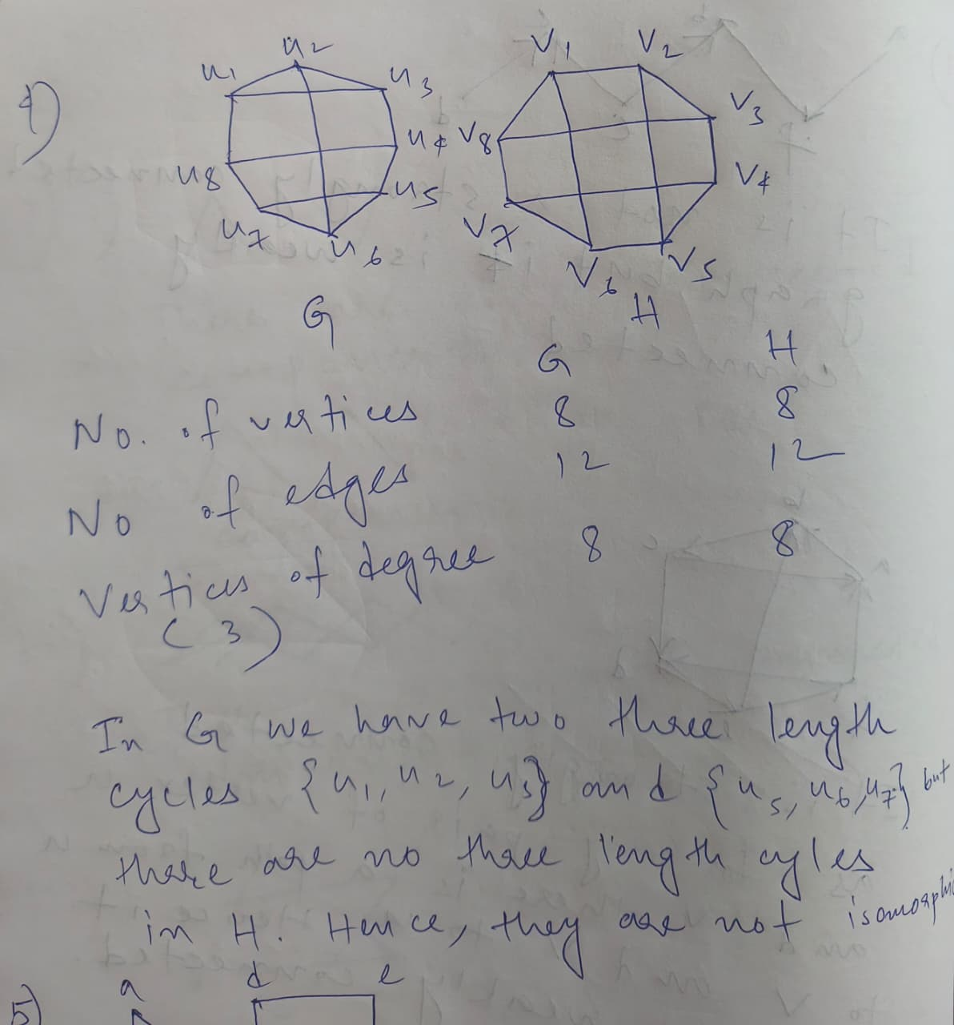

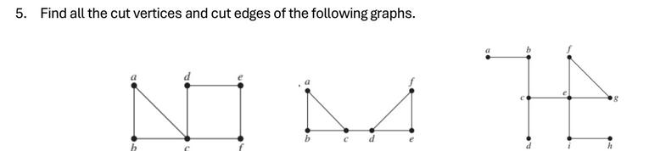
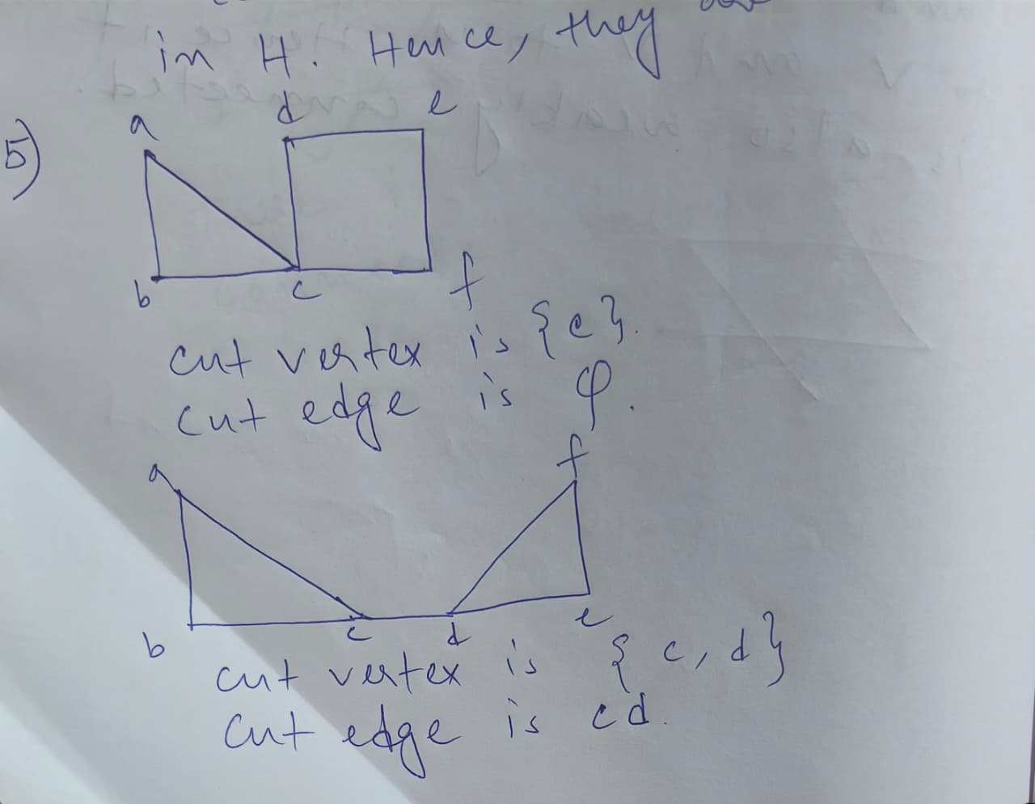
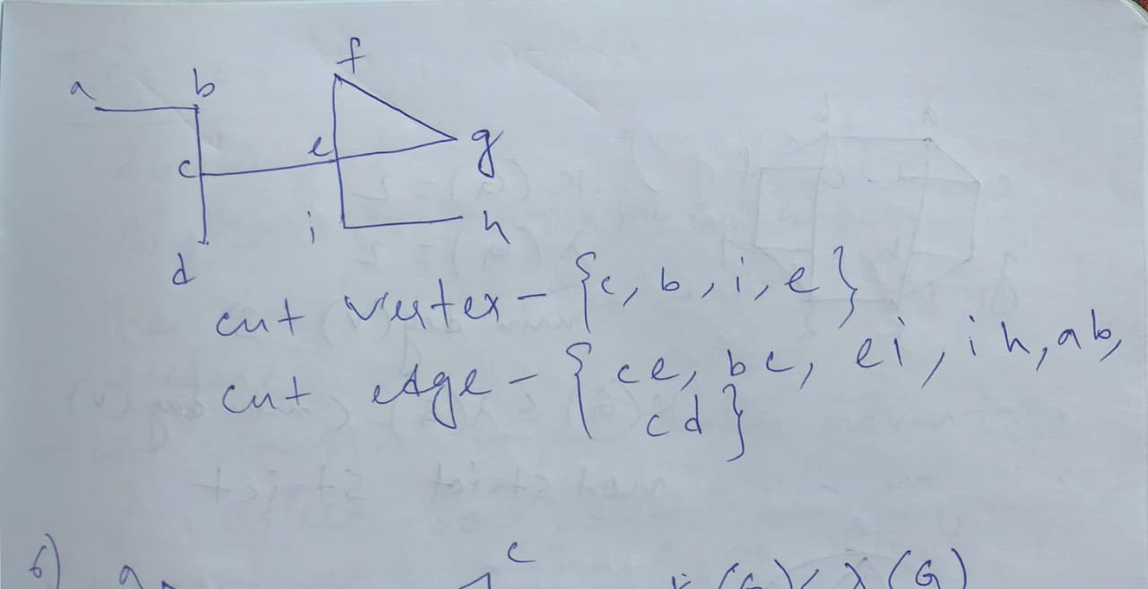

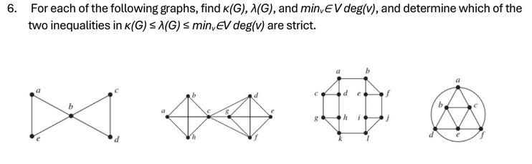
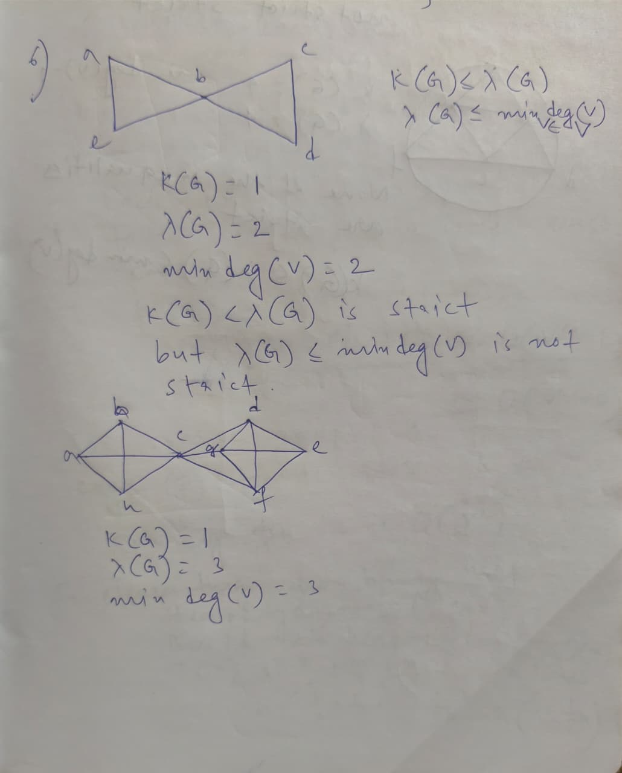
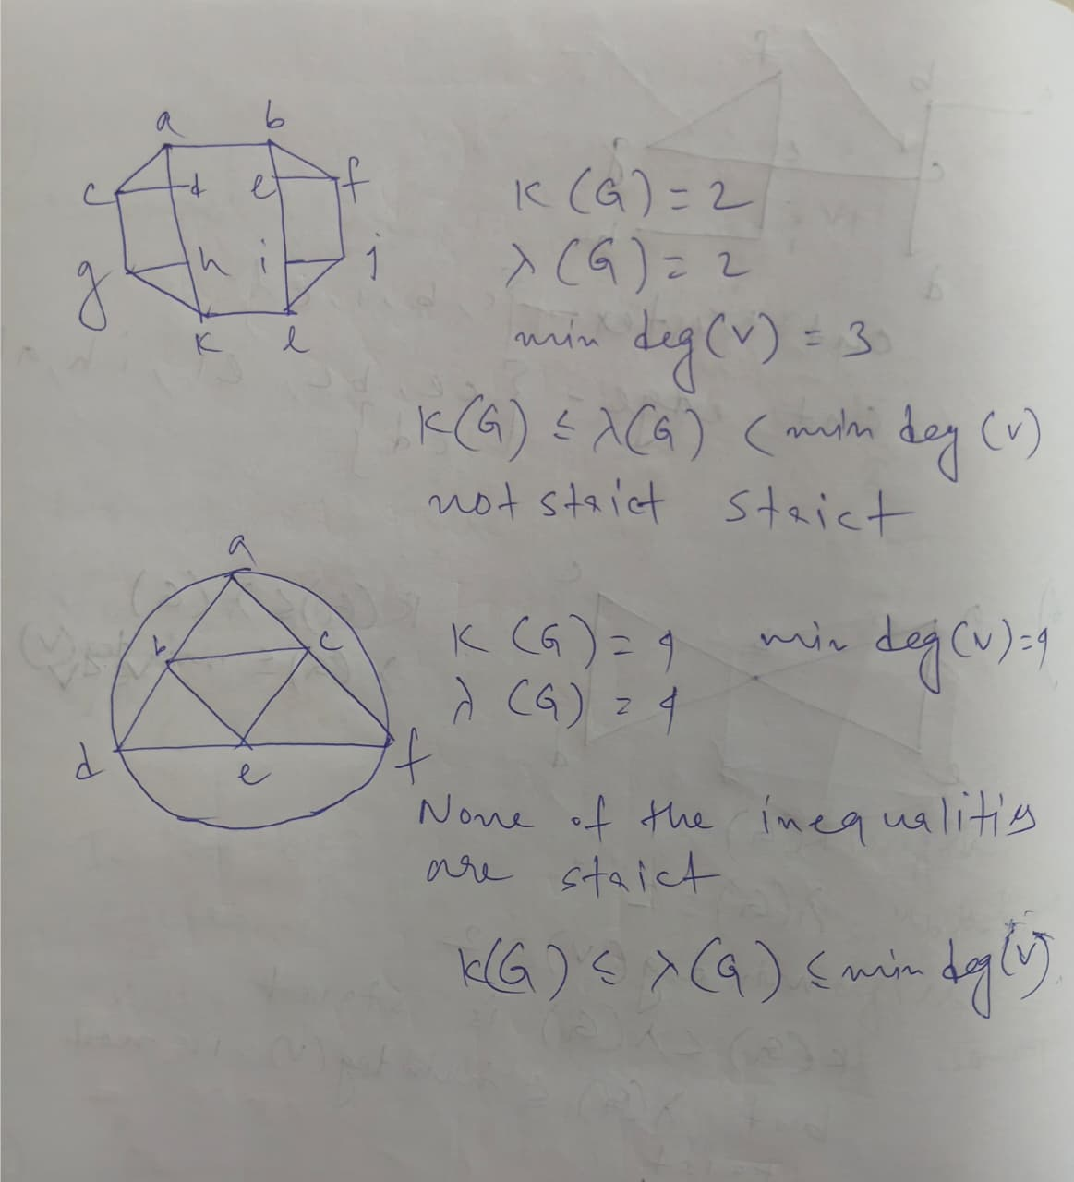
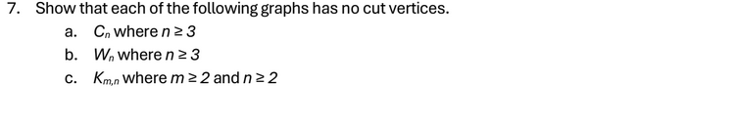
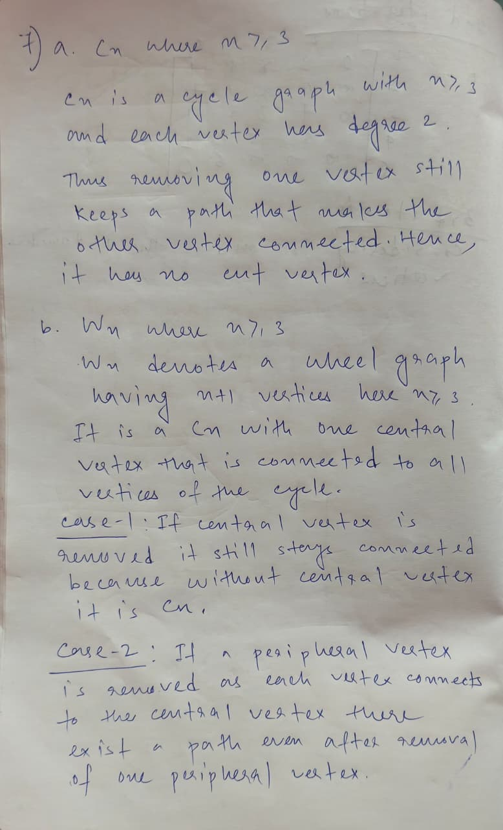
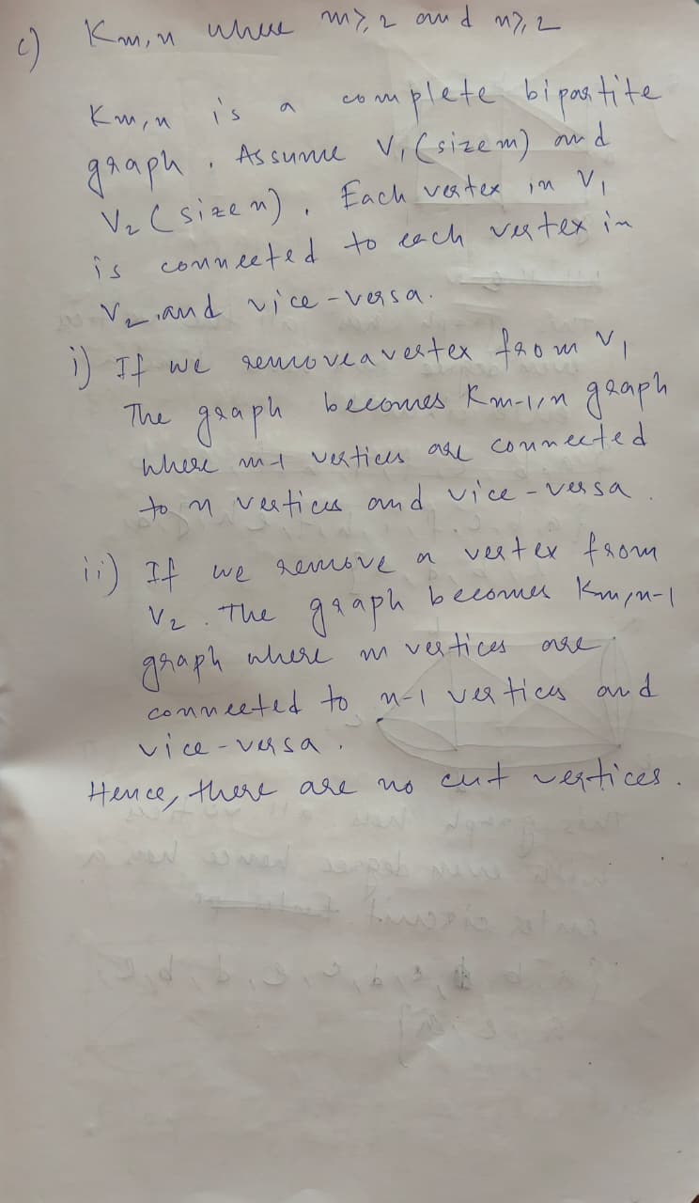
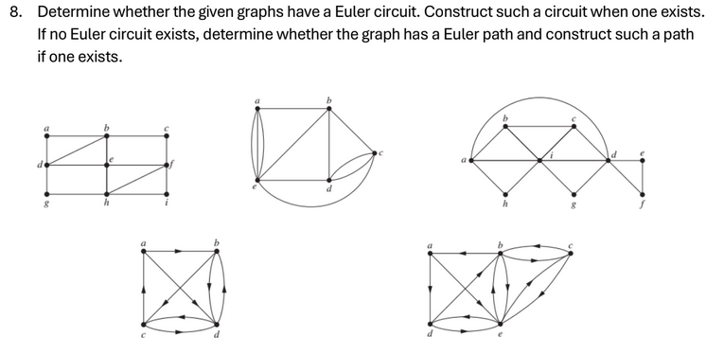
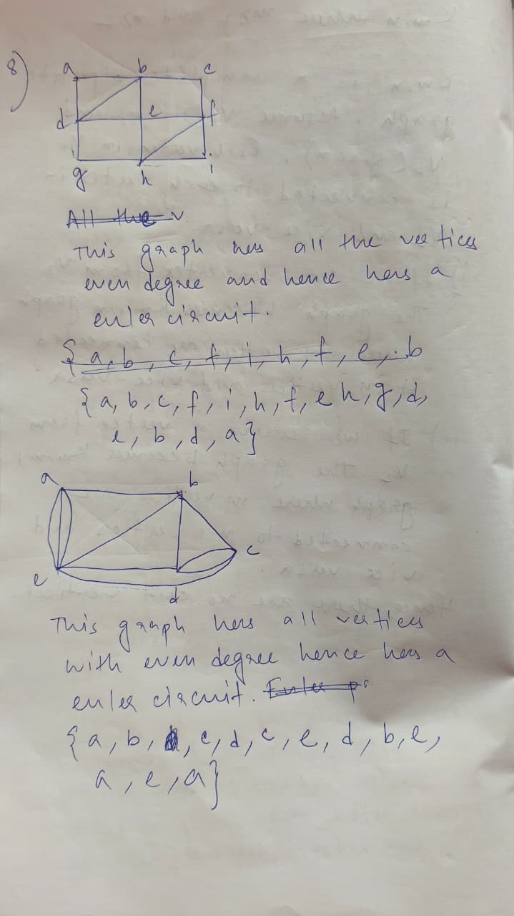
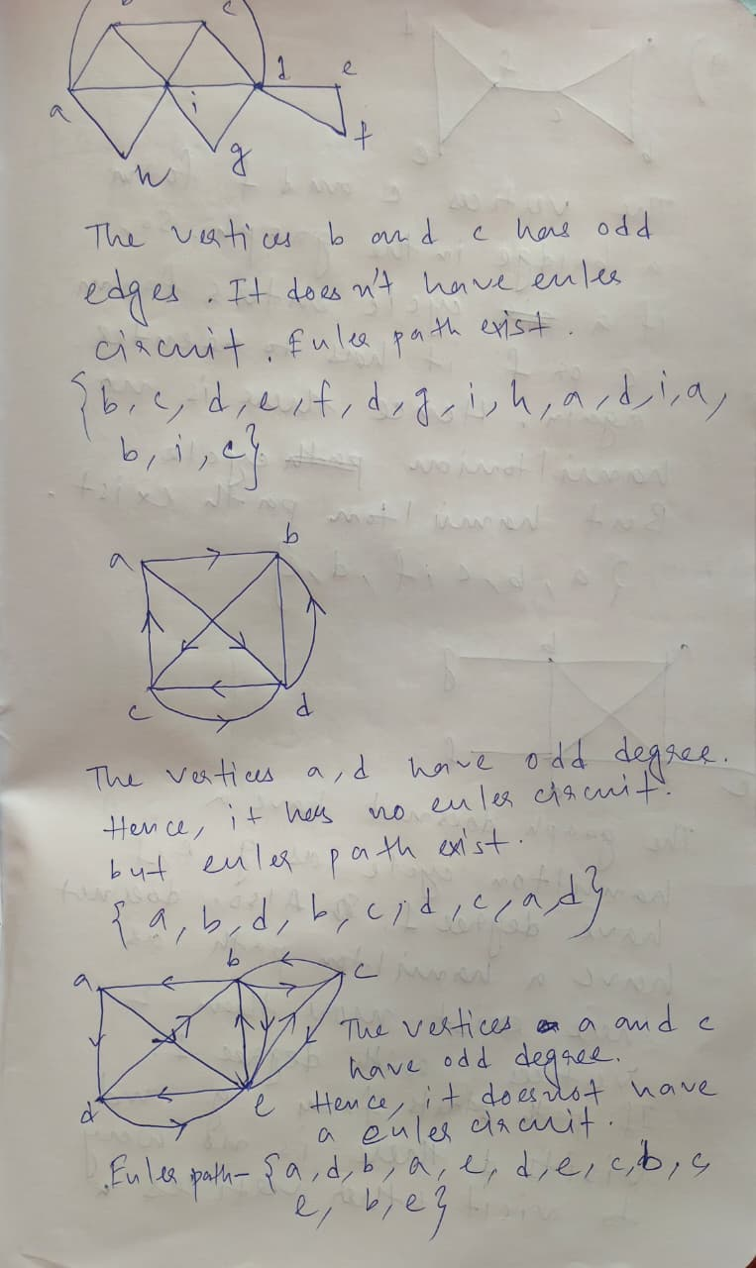
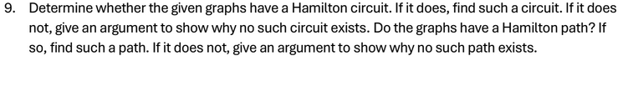
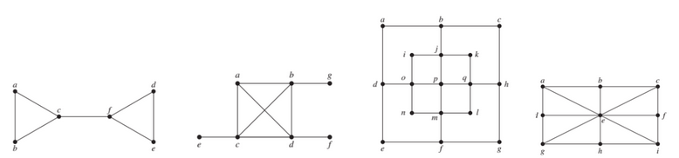
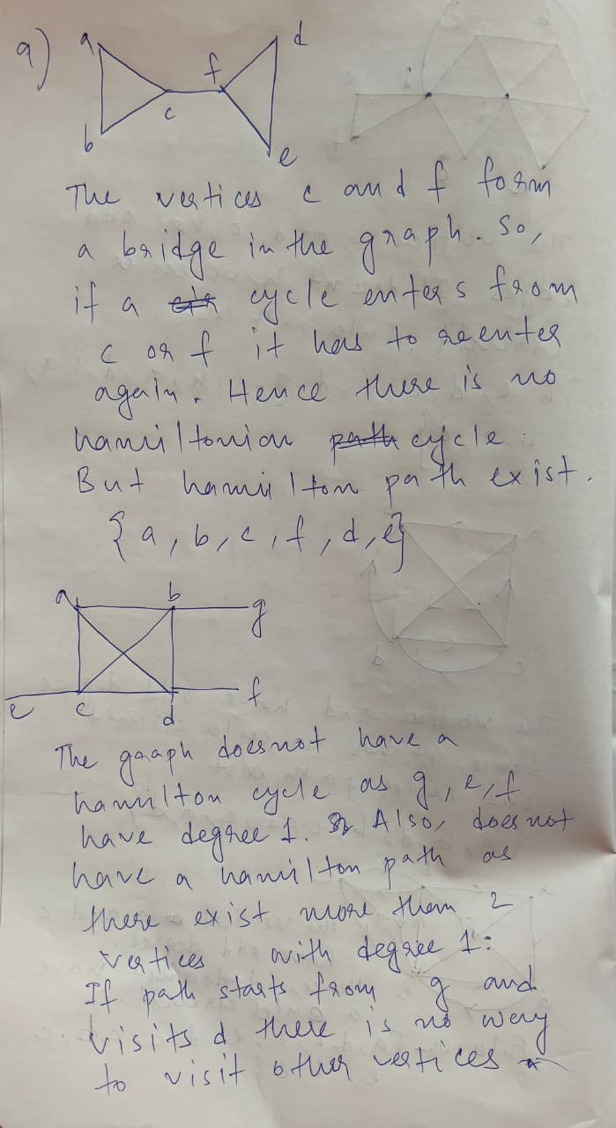
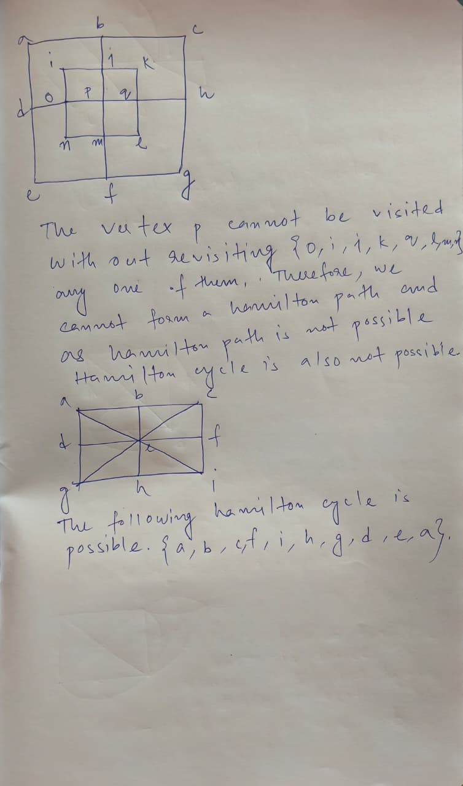

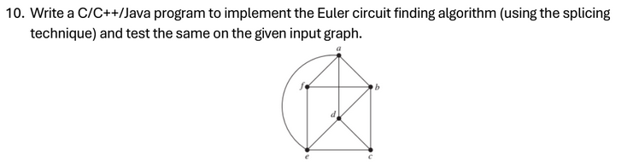
#include <bits/stdc++.h>
using namespace std;

void eraseEdge(vector<vector<int>>& adj, int u, int v) {
adj[u].erase(find(adj[u].begin(), adj[u].end(), v));
adj[v].erase(find(adj[v].begin(), adj[v].end(), u));
}

vector<int> buildCycle(vector<vector<int>>& adj, int start) {
vector<int> cycle;
stack<int> st;
st.push(start);

while (!st.empty()) {
int u = st.top();
if (!adj[u].empty()) {
int v = adj[u].back();
eraseEdge(adj, u, v);
st.push(v);
} else {
cycle.push_back(u);
st.pop();
}
}
return cycle;
}

vector<int> getEulerianCircuit(vector<vector<int>>& adj) {
for (int i = 0; i < adj.size(); i++) {
if (adj[i].size() % 2 != 0) {
return {};
}
}

int start = -1;
for (int i = 0; i < adj.size(); i++) {
if (!adj[i].empty()) {
start = i;
break;
}
}
if (start == -1) return {};

vector<int> circuit = buildCycle(adj, start);

bool moreEdges = true;
while (moreEdges) {
moreEdges = false;
for (int i = 0; i < circuit.size(); i++) {
int u = circuit[i];
if (!adj[u].empty()) {
vector<int> extraCycle = buildCycle(adj, u);
circuit.insert(circuit.begin() + i + 1, extraCycle.begin(), extraCycle.end() - 1);
moreEdges = true;
break;
}
}
}
return circuit;
}

int main() {
vector<vector<int>> adj = {
{1,3,4,5},
{0,2,3,5},
{1,3,4},
{0,1,2,4},
{0,5,3,2},
{0,1,4}
};

vector<int> circuit = getEulerianCircuit(adj);

if (circuit.empty()) {
cout << "No Eulerian circuit exists." << endl;
} else {
cout << "Eulerian circuit: ";
for (int v : circuit) {
cout << v << " ";
}
cout << endl;
}
return 0;
}

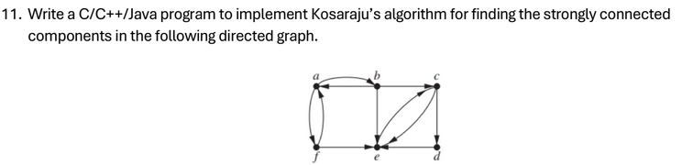
# include <bits/stdc++.h>
using namespace std;
void dfs(int node,vector<int>&vis,vector<int>adj[],stack<int>&st){
vis[node] = 1;
for(auto it : adj[node]){
if(!vis[it]){
dfs(it,vis,adj,st);
}
}
st.push(node);
}
void dfsOnTranspose(int node,vector<int>&vis,vector<int> adjT[],vector<char>&components){
vis[node] = 1;
components.push_back('a' + node);
for(auto it : adjT[node]){
if(!vis[it]){
dfsOnTranspose(it,vis,adjT,components);
}
}
}
int main(){
// 0 -> a, 1 -> b, 2 -> c, 3 -> d, 4 -> e, 5 -> f
vector<int>adj[6];
adj[0] = {1,5};
adj[1] = {0,2,4};
adj[2] = {4,3};
adj[3] = {4};
adj[4] = {2};
adj[5] = {4, 0};
vector<int>vis(6,0);
stack<int>st;
//Step 1 : Ordering based on finishing time
dfs(0,vis,adj,st);
//Step 2 : Transpose the graph
vector<int>adjT[6];
for(int i=0;i<6;i++){
vis[i] = 0;
for(auto it : adj[i]){
adjT[it].push_back(i);
}
}
//Step 3 : Do DFS based on finishing time
int sccs = 0;
vector<string> components;
while(!st.empty()){
int node = st.top();
st.pop();
if(!vis[node]){
vector<char>components;
dfsOnTranspose(node,vis,adjT,components);
sccs++;
for(auto it : components){
cout << it << " ";
}
cout << endl;
}
}
cout << "Number of Strongly Connected Components: " << sccs << endl;
return 0;
}
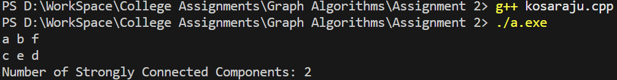
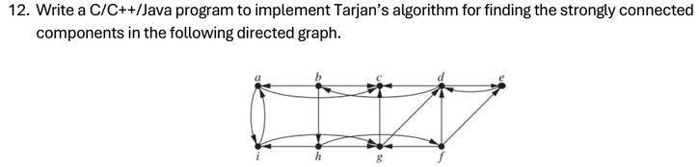
#include <bits/stdc++.h>
using namespace std;
int id = 0;
vector<int> indexes, lowlink;
stack<int> st;
vector<bool> onStack;
vector<vector<int>> sccs;
void dfs(int node, vector<vector<int>>& adj){
indexes[node] = lowlink[node] = id++;
st.push(node);
onStack[node] = true;
for(auto it : adj[node]){
if(indexes[it] == -1){
dfs(it, adj);
lowlink[node] = min(lowlink[node], lowlink[it]);
} else if(onStack[it]){
lowlink[node] = min(lowlink[node], indexes[it]);
}
}
if(lowlink[node] == indexes[node]){
vector<int> component;
while(true){
int curr = st.top();
st.pop();
onStack[curr] = false;
component.push_back(curr);
if(curr == node) break;
}
sccs.push_back(component);
}
}
void tarjan(vector<vector<int>>&adj){
int n = adj.size();
indexes.resize(n, -1);
lowlink.resize(n, -1);
onStack.resize(n, false);
id = 0;
while(!st.empty()) st.pop();
sccs.clear();
for(int i=0;i<n;i++){
if(indexes[i] == -1){
dfs(i, adj);
}
}
}
int main(){
vector<vector<int>> adj = {
{2,8},
{0,7,2},
{},
{1,4},
{3},
{4,6,3},
{2,3},
{5,6,8},
{0,6}
};
tarjan(adj);
cout << "Number of Strongly Connected Components: " << sccs.size() << endl;
for(int i=0;i<sccs.size();i++){
cout << "SCC " << i+1 << ": ";
for(auto it : sccs[i]){
cout << (char)('a' + it) << " ";
}
cout << endl;
}
return 0;
}
